**Pages: Card, List types and Action Controls**

Please submit the screenshots as shown below

**Card Page as shown below**

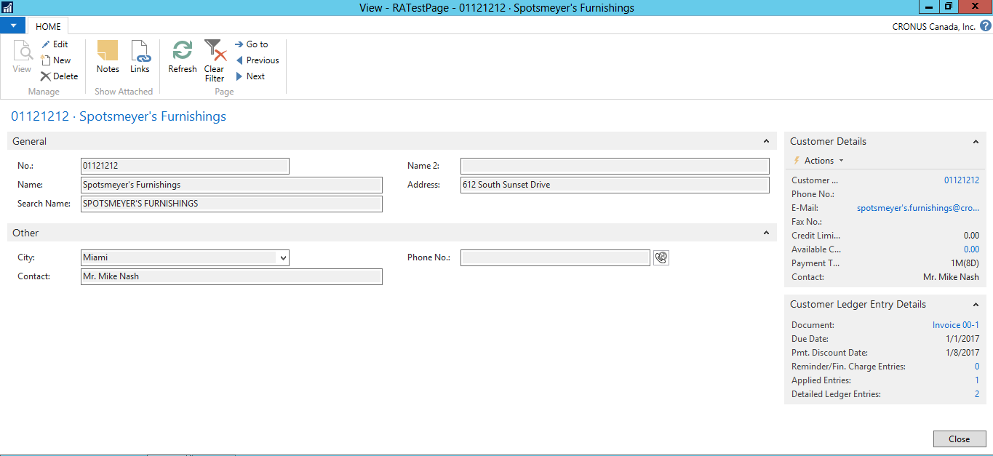

**List Page as shown below**

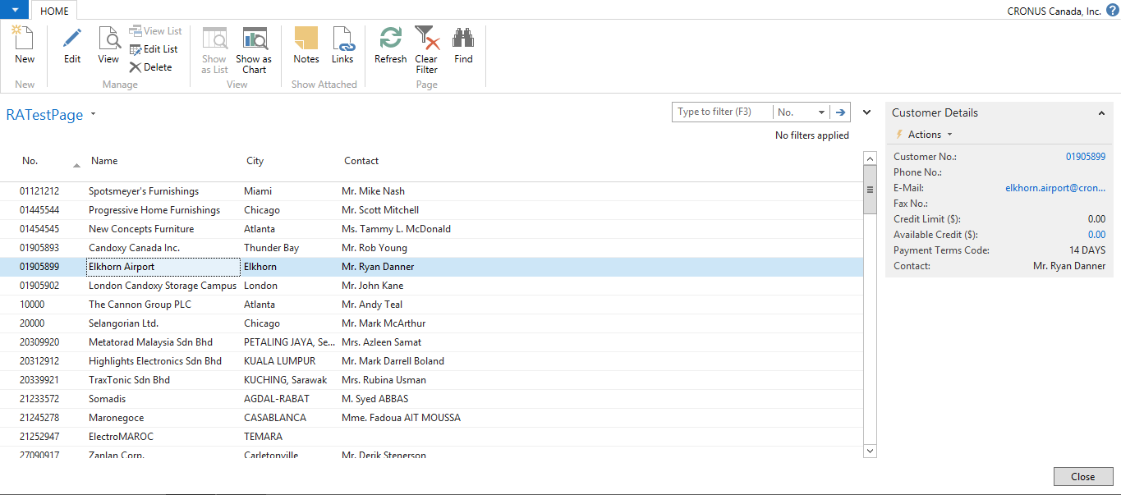

**Page Action Controls as shown below**

**NOTE: For Inventory-List action, I link it to ID ‘701’ in the video. If you don’t have this ID, use any other inventory report ID.**

